# Introduction

The OpenAT Switch Latch was developed when a number of assistive switch users (Ean Price, Tom Cretain) requested the ability to control lights and other devices in a semi permanent manner, but do so, utilizing their preferred momentary assistive switches.

The intended users of the OpenAT Switch Latch are those who require a momentary switch to act as a toggle switch (aka latched switch), allowing the user to turn on for an extended time with a quick tap, and off again with another quick tap.

# Research

## Commercial Options

### AbleNet Dual Switch Latch & Timer

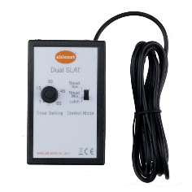The **Dual Switch Latch & Timer** by Adaptive Tech Solution **$305.22**

[Switch Latch & Timer (adaptivetechsolutions.com)](https://www.adaptivetechsolutions.com/dual-switch-latch-timer/)

Most switches give switch users momentary control of their switch adapted toys or appliances. Meaning, when you press your switch, your toy or appliance will operate only for the time that you are holding down the switch. The Dual Switch Latch and Timer gives switch users more control of their devices by adding time and latch modes of control. You can setup two switches into the Switch Latch and timer. The switches will operate their corresponding toy or appliance independently of each other in the same mode of control.

### Switch Capable Continuous Control Unit

can be used to operate most AC appliances from up to 20 feet away**.** List Price: **$315.40 Sale** Price: **$220.56** (Save 30%)

The Switch Capable Continuous Control Unit can be used to operate most AC appliances from up to 20 feet away. Activate the remote transmitter with a capability switch after plugging the appliance into the receiver. In latch mode, the appliance will run until the switch is pressed again; **in momentary mode, it will turn on when the switch is pressed and off as soon as the switch is released.**

### PowerLink 4

[**https://www.ablenetinc.com/powerlink-4-north-america/**](https://www.ablenetinc.com/powerlink-4-north-america/)

**Cost: $330 USD + Shipping**

Used to turn on appliances that are powered from a wall outlet.

### Latch Box

Link: <https://oneswitch.org.uk/art.php?id=276>

Cost: £40 (+ postage) (~$62 CAD + shipping)

Power: 3x AAA batteries OR USB (Micro-B)

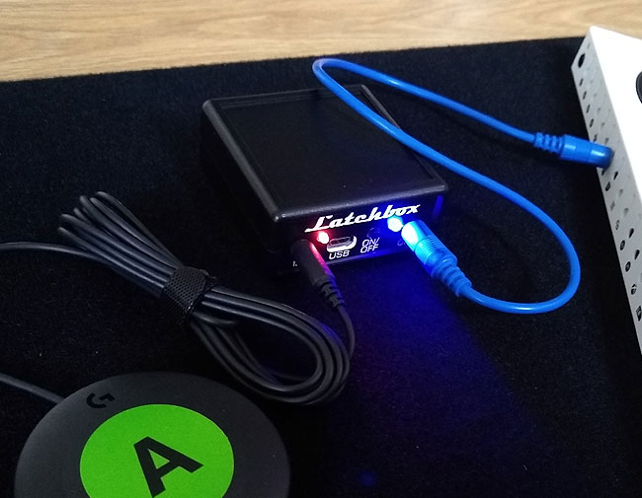

### Tiny Switchy Version 1.4

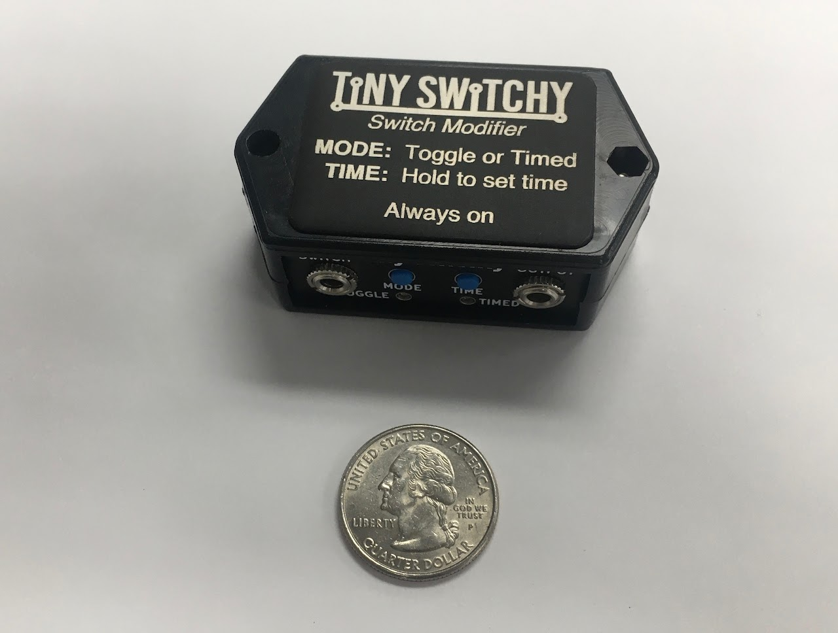

**Information:** [**https://www.tinyswitchy.com/**](https://www.tinyswitchy.com/)

**Purchase:** [**https://www.littlelaketech.com/product/tiny-switchy/1#**](https://www.littlelaketech.com/product/tiny-switchy/1)

Cost: $40 USD + Shipping. Does not currently ship to Canada.

* Toggle and timed-output modes
* 3V CR2032 Coin cell battery
* Expected battery life: 3 years
* Small
* >1 A switched current
* Maximum hold time: 68 minutes

## DIY Versions

### Self-Retention for Button on Xbox Adaptive Controller

Link: <http://www.johannes-online.de/wordpress/?page_id=1063>

* Based on request from Melly (<https://meilert.net/>) (<https://twitter.com/melly_maeh>)
* LED to indicate status

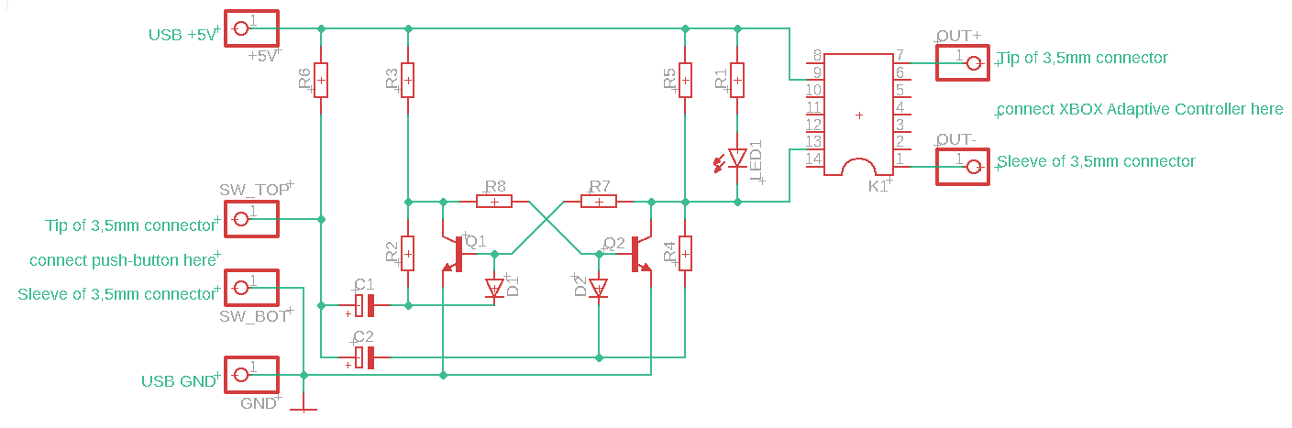

|  |  |  |
| --- | --- | --- |
| **Position** | **Designation** | **Number** |
| C1, C2 | Electrolytic capacitor 22 μF | 2 |
| D1, D2 | Diode 1N4007 | 2 |
| K1 | Reed Relay V23100-V4005-A010 | 1 |
| LED1 | LED 5mm, red | 1 |
| Q1, Q2 | Transistor BC547 | 2 |
| R1, R2, R3, R4, R5 | Resistor 1k Ohm | 5 |
| R6, R7, R8 | Resistance 10k Ohm | 3 |

30 mm x 70 mm Grid board

<https://youtu.be/RP3qliKeLuE>

<https://youtu.be/2iWaojsw_O0>

# Requirements

## Goals

|  |  |
| --- | --- |
| G01 | Enable a momentary assistive switch to toggle (latch) a switch controllable device. |
| G02 | To make the device with a relay output capable of driving powered devices. |
| G03 | To make the unit accept 3.5 mm assistive switches. |
| G04 | Battery life of XX |

## Functional Requirements

|  |  |
| --- | --- |
| F01 | When off, the toggle circuit must activate (and stay active) when a switch input is triggered. |
| F02 | When on, the toggle circuit must de-activate (and stay off) when a switch input is triggered. |
| F03 | The toggle circuit must contain some form of switch debouncing circuitry to keep operation reliable. |
| F04 | The toggle circuit should default to a non-closed connection. |

## Non-functional Requirement

|  |  |
| --- | --- |
| NF01 | The Toggle Adapter should require no mechanical force to operate. |
| NF02 | The toggle Adapter should have a long battery life. |
| NF03 | The toggle Adapter should use a minimum of electronic parts. |

## Constraints

|  |  |
| --- | --- |
| C01 | The MMC Toggle Adapter must be able to be constructed using basic ‘maker’ tools. |
| C02 | The MMC Toggle Adapter should be able to be disinfected using detergent and alcohol. |

# Ideation

Some electronic toggle circuit diagrams were sourced from the internet as potential candidates for forming the core of the MMC Toggle Adapter. The ideal candidate circuit will have inexpensive parts that are small in number and are easy to construct with basic hand tools.

# Conceptual Design

## Toggle Circuit Options

### Concept 1: Two Transistor Flip-Flop

Two Transistor Flip Flop circuit

This circuit comprises of just two low cost and extremely available transistor and a reasonable number of resistors and capacitors. As no microchip is required, many electronics engineers and hobbyists will find they already posses the needed garden variety parts. The main downsides are that more parts are needed, and that the power consumption of this concept is highest.

Concept 1 prototype was built on Perfboard using parts already in stock. As the parts count is quite high having a PCB design would be best for the final version The diode steering works reliably, as the discrete bipolar transistors have a higher noise immunity than CMOS type input circuitry. The downside comes in the form of higher power consumption, which can be a problem if using batteries.

### Concept 2: 555 Timer IC



555 Timer IC

The venerable 555 Timer IC is used for the second concept. Note that the lower power CMOS version is used here. The chip is easy to solder as it only has eight pins. Power consumption is about 80 micro amps, the second lowest.

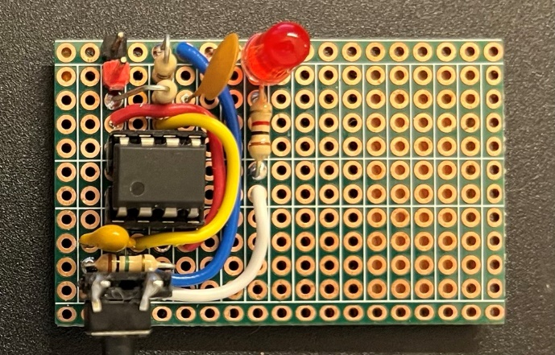

The concept 2 prototype was built on double sided Perfboard using parts ordered from Digi-Key. Note that this circuit makes use of the CMOS version of the 555 timer IC, which is considerably more energy efficient than the original (but still available) bipolar version. Putting this one together was noticeably easier, as the total part count is nearly half that of the discrete transistor version.

### Concept 3: Dual Flip Flop IC

The low power CMOS CD4027BCN Dual Flip Flop IC is used here. While the IC has 16 pins to solder, they can all be soldered quickly because all pins go into a PCB together, and can be soldered quickly due to being placed in rows. Note that this chip has the lowest power consumption of the concepts presented here. Current draw is a mere .7 micro amps, so this circuit could run on a coin cell for months.

Concept 3 prototype was built on double sided Perfboard using parts ordered from Digi-Key. The low power CMOS CD4027BCN Dual Flip Flop IC is used here. While the IC has 16 pins to solder, they can all be soldered quickly as they are in rows, and all go in together. Note that this chip has the lowest power consumption of the concepts presented here. Current draw is a mere .7 micro amps, so this circuit could run on a coin cell for months. An additional bonus of this design is that this IC can be used to make two toggle switches without having to buy another chip. It just requires an extra three resistors, and a capacitor of the same values.

### Concept 4: Quad NAND Gate IC

CD40107BM96 dual NAND gate

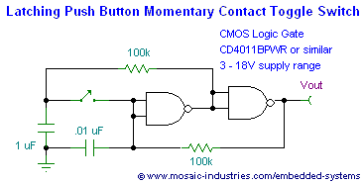

Concept 3 prototype was built on double sided Perfboard using parts ordered from Digi-Key. The low power CMOS CD4027BCN Dual Flip Flop IC is used here. ng, so the design was changed to incorporate a bearing instead.

### Concept 5 Flip Flop with buffered inputs

The CD74HC73E was chosen when it was determined that the input circuitry of the flip flop was vital to the behaviour of the latching circuit when fed with a mechanical switch instead of normally expected CMOS or TTL level circuitry. It was found, that despite identical part numbers, parts from different manufacturers had different input structures suitable for switch inputs. We liked the CD74HC73E because it had an input buffer that could condition a rougher input signal into a usable form, without having to add extra circuitry. Additionally, this chip drew remarkably little power, while still being able to provide decent output drive.

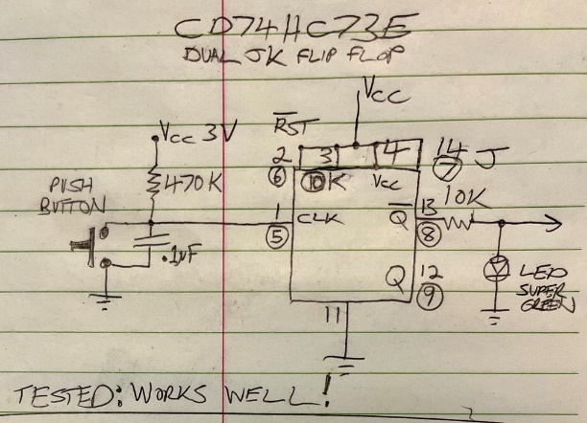

### Component List:

## Circuit Comparison

|  |  |  |  |  |  |
| --- | --- | --- | --- | --- | --- |
|  | Concept 1  Discrete transistor Flip-Flop | Concept 2  555 Timer IC | Concept 3  CD4027 Flip-Flop IC | Concept 4  Quad NAND gate IC | Concept 5 TI CD74HC73E Dual Flip Flop |
| Current Draw  (all at 3.3V) | 959 uA (2.37 mA + LED) | 88-90 uA (1.35+LED) | .2 uA (86.2 uA+LED) | 4.9 uA | .4uA  67uA with LED on |
| Noise Immunity | Excellent  withstood 1.7 VAC RMS) on input | Poor: pin 2 input of 555 highly susceptible to noise .25 VAC RMS | Acceptable:  .85 VAC RMS | Fail  Circuit fails to change states when wires are added. | Excellent  Works even with longer cables |
| Price | Under $20 for core circuitry | Under $20 for core circuitry | Under $20 for core circuitry | Under $20 for core circuitry | Under $20 for core circuitry |
| Projected ease of build | Moderate | Very Easy | Easy | Easy | Easy |

## Toggle Circuit

As the leading design from the comparison table is using the CD4027 IC, we will focus on the CD4027. Note that all the test circuits omitted a solid state relay output circuit, which we will add to the final design, and will become sum of the two schematics below:

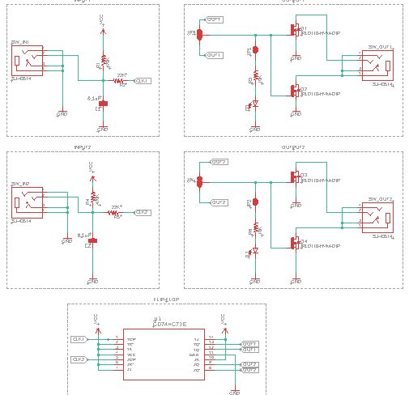

### Dual Version (Two Channels)

### Dual Construction Method Comparison

|  |  |  |  |  |
| --- | --- | --- | --- | --- |
|  | PCB | PCB-A Thru-hole | PCB-A SMD | Protoboard |
| Number of components | 22 | N/A | N/A | N/A |
| Number of polarized components | 7 | N/A | N/A | N/A |
| Number of connections | 72 | N/A | N/A | N/A |
| Cost | $28 CAD | N/A | N/A | N/A |
| Size | 56mm x 50mm | N/A | N/A | N/A |
| Maker Difficulty | Medium | Medium | High | High |

### Mono Version 1 (One Channel)

### Mono Version 2 (One Channel)

### Mono Construction Method Comparison

|  |  |  |  |  |
| --- | --- | --- | --- | --- |
|  | PCB | PCB-A Thru-hole | PCB-A SMD | Protoboard |
| Number of components | 12 | N/A | N/A | N/A |
| Number of polarized components | 4 | N/A | N/A | N/A |
| Number of connections | 46 | N/A | N/A | Additional jumpers needed on protoboards |
| Cost | $20 CAD | N/A | N/A | N/A |
| Size | 56mm x 38mm or 52mm x 44mm | N/A | N/A | Additional area may be needed |
| Maker Difficulty | Easy | Moderate | SMD soldering skills needed | Recommend Experienced builders only |

## Power Source

### AAA Cells

Pros

* Rechargeable

Cons

* Can leak over long time durations

### Lithum 3V Cells

Pros

* High energy density, unlikely to leak.

Cons

- Potential fire risk for some brands/formulations

Comparison

AAA cells are more readily available in stores, but 3V lithium batteries are less common, though CR2032 coin cells are reasonably common.

## Layout

## Visual Feedback

### (Nothing)

### LED

High brightness (efficient) green LED used with higher value resistor for lower current draw.

## Test Button

No test button is chosen.

## Power Switch

Internal jack switch

External slide switch

# Detailed Design

# OpenAT Switch Latch V1.0

### Channels

This design uses a single channel.

### Visual Feedback

This design has a single green LED. When the output is closed, the LED is on. When the output is open, the LED is off. There is a cuttable junction for disabling this feature.

### Power Source

3V Lithium CR2032 Cell in a thru-hole mounted holder.

### Power Switch

This design has a sliding power switch.

### Enclosure

This design has a multipart 3D printed enclosure fastened with screws. The enclosure consists of a top, bottom, battery cover, and switch slide. The PCB is affixed inside to the top portion of the enclosure. The bottom of the enclosure is affixed to the top of the enclosure using four (4) screws. The battery cover is held in with a single screw.

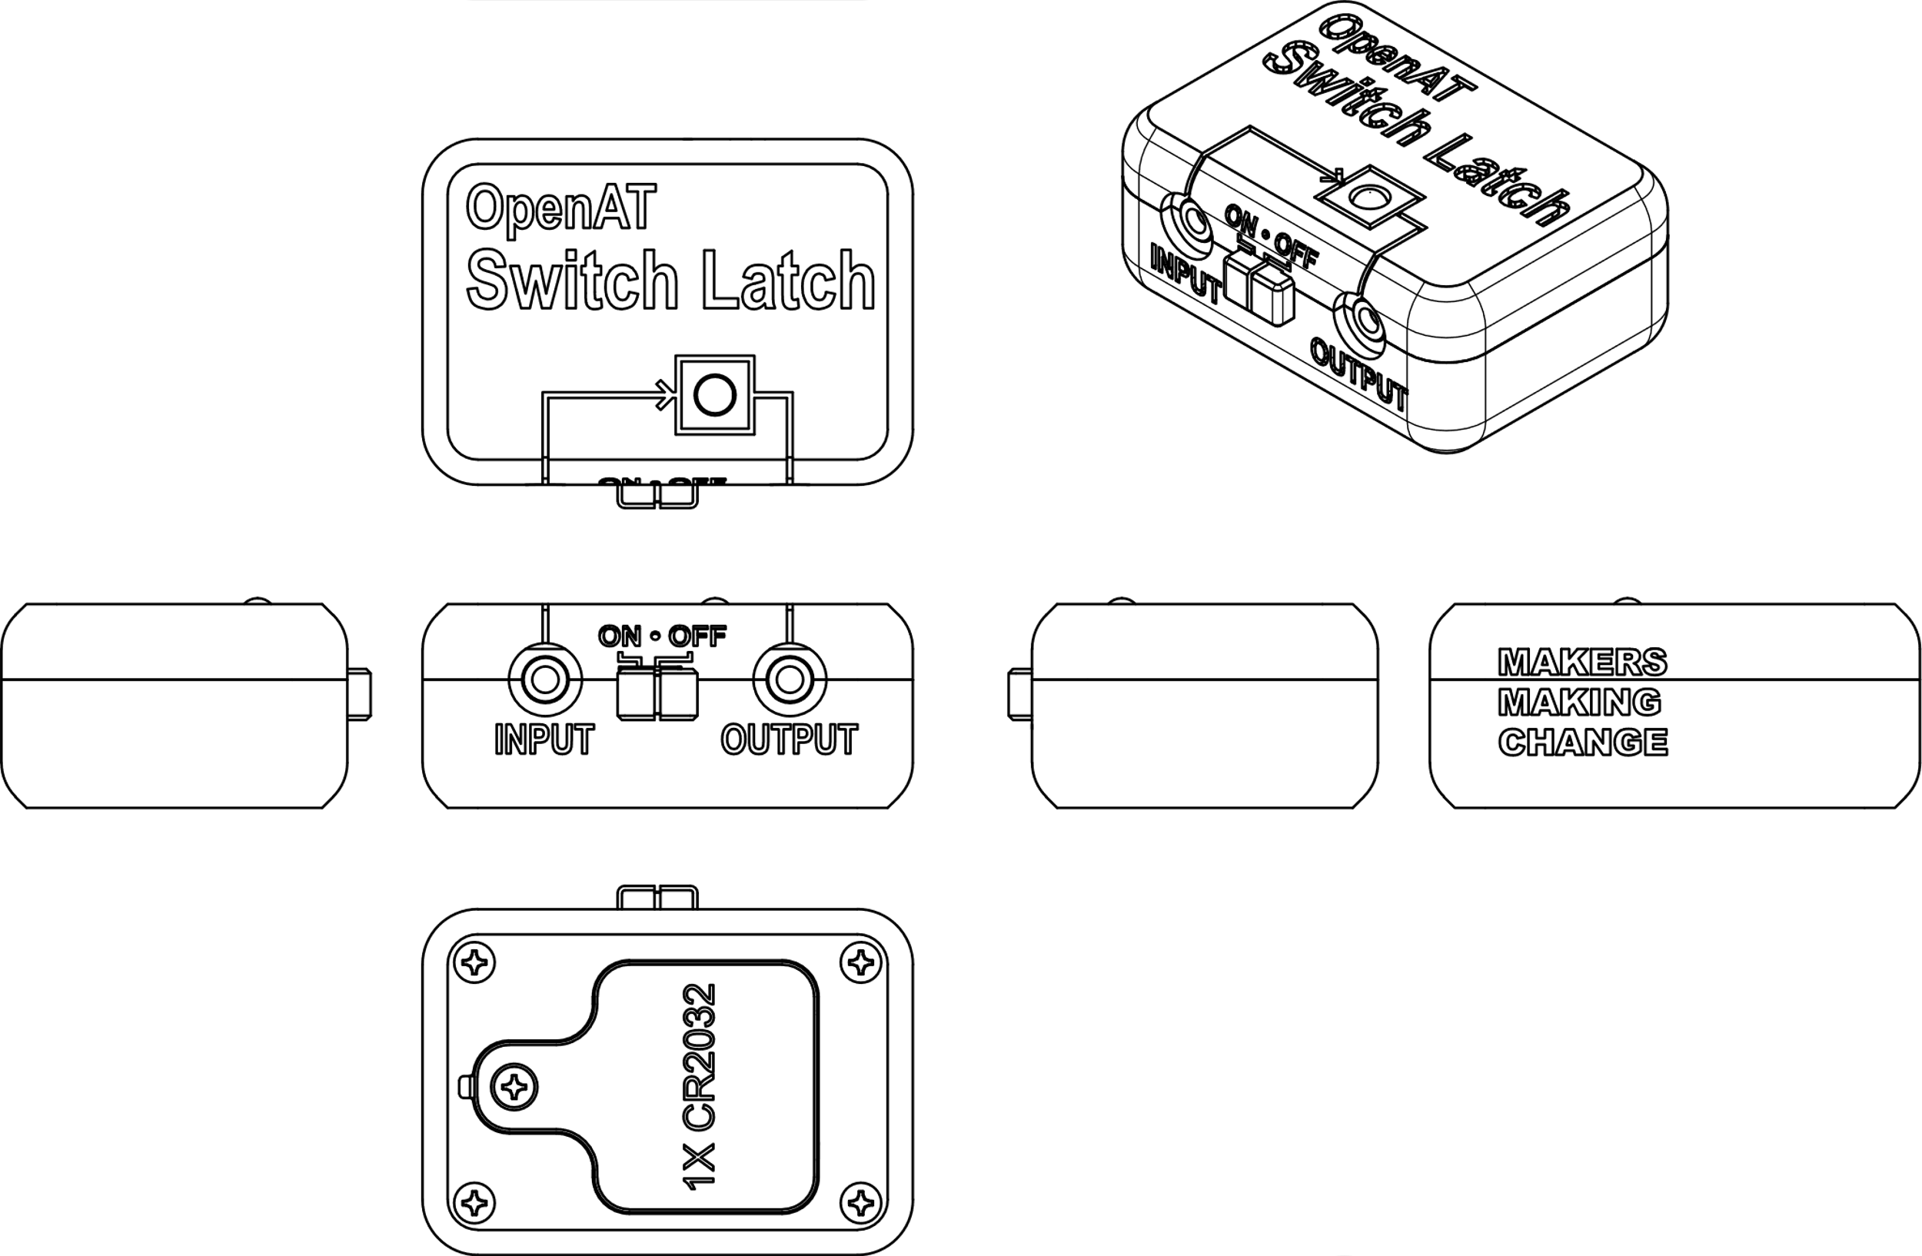

### Layout

### Design Changes

* Add footprint for right angle switch with a cut-able bypass junction (switch on by default)
* Add Jack with built in switch to act power switch and mark switch pins on PCB (to allow for bypass in case of failure I.e. Digi-Key **SJ-3566AN** or equivalent)
* Add Clearance around the PCB and battery holder (2.5-3 mm?)
* Add central hole on PCB same size as 4 corner holes.
* Change Dimensions of PCB to 60 x 40 mm
* Move alternate output cut-able trace to under battery case (allows for testing but not final use)
* Move input and output jacks apart as much as possible (but allow 1mm clearance to case posts)
* Move the power switch between input and output jacks
* Move LED to right of switch
* Change the JK flip flop IC to Texas Instruments CD74HC73E, as CD4027 from Fairchild was no longer available from Digi-Key or Mouser, and the newer revisions from other vendors had gate input structures that proved unsuitable for use with a mechanical switch input, as this type of circuit is normally fed with pulses from another logic IC

# Opportunities for Improvement

* Modify design with extra capacitor (or diode) to boost the noise immunity somewhat.
* Use non polarized ceramic capacitor for power decoupling.
* ~~Modify circuit to become a dual toggle switch, as only six extra parts are required.~~

Printed Circuit Board

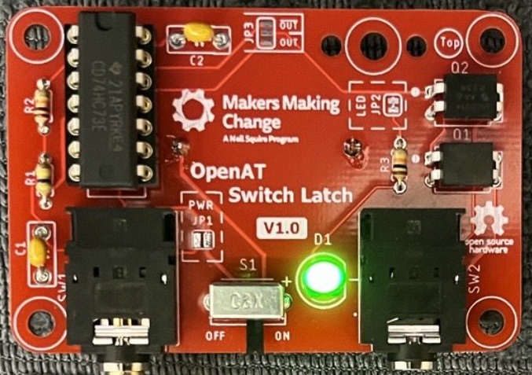

Theory of Operation

* Pressing the button causes the input of the first JK Flip Flop to go low. This triggers the Flip Flop output to change to its opposite state, and remaining that way (even after the button is released, and the input goes high again). Only a fresh button press will change the output state. The output of the Flip Flop feeds a green LED for state indication, via a 10K resistor. The Flip Flop output is also connected to two MOSFETs, which are wired together to function as a solid state relay. Thus, when the Flip Flop output goes high, and the LED turns on, the output jack also becomes conductive, turning on any connected and activatable device.

JP1

* Default: Unsoldered
* Purpose: This can be soldered to bypass the input jack switch (i.e., the device’s power is controlled only by the power switch)

JP2

* Default: Soldered
* Purpose: This can be cut to disable the Output LED.

JP3

* Default: Reverse toggle switch operation

Final PCB Changes

* Change name
* Move JP3 to be accessible when device is constructed.